

**Name** : KAUTA MARVIN

**Registration Number** : S20B23/204

**Faculty/School** : SCIENCE AND TECHNOLOGY

**Course** : BACHELORS OF SCIENCE IN COMPUTER SCIENCE

**Lecturer** : ***mR LUBAMBO SIMON***

**ESTIMATION**

Estimation is the process of finding an estimate, or approximation, which is a value that can be used for some purpose even if input data may be incomplete, uncertain, or unstable.

Estimation determines how much money, effort, resources, and time it will take to build a specific system or product. Estimation is based on −

* Past Data/Past Experience
* Available Documents/Knowledge
* Assumptions
* Identified Risks

**ESTIMATION TECHNIQUES**

Estimation techniques are of utmost importance in software development life cycle, where the time required to complete a particular task is estimated before a project begins. Estimation is the process of finding an estimate, or approximation, which is a value that can be used for some purpose even if input data may be incomplete, uncertain, or unstable.

**ESTIMATION TECHNIQUES - Wideband Delphi**

* Named after the Oracle at Delphi (Ancient Greece)
* A consensus-based estimation technique for estimating effort.
* Developed in the 40s at RAND Corp as a forecasting tool. Since being adopted across many industries for estimation.
* Proven to be a very effective estimation tool, and it lends itself well to software projects.
* Barry Boehm & John Farquhar originated the Wideband variant of Delphi in the 70s - **Called "wideband"** as compared to the existing Delphi method, it involved greater interaction & more communication between participants.
* Popularized by Boehm's book Software Engineering Economics (81).
* A variant of Wideband Delphi was developed by Neil Potter and Mary Sakry of The Process Group.

The term "**wideband**" is used because, compared to the Delphi Method, the Wideband Delphi Technique involved greater interaction and more communication between the participants.

In Wideband Delphi Technique, the estimation team comprises the project manager, moderator, experts, and representatives from the development team, constituting a 3-7 member team.

**There are two meetings −**

* Kickoff Meeting
* Estimation Meeting

**Wideband Delphi Technique – Steps**

**Step 1** − Choose the Estimation team and a moderator.

**Step 2** − The moderator conducts the kickoff meeting, in which the team is presented with the problem specification and a high-level task list, any assumptions, or project constraints. The team discusses the problem and estimation issues if any. They also decide on the units of estimation. The moderator guides the entire discussion monitors time and after the kickoff meeting, and prepares a structured document containing problem specification, a high-level task list, assumptions, and the units of estimation that are decided. He then forwards copies of this document for the next step.

**Step 3** − Each Estimation team member then individually generates a detailed Work Breakdown Structure(WBS), estimates each task in the WBS, and documents the assumptions made.

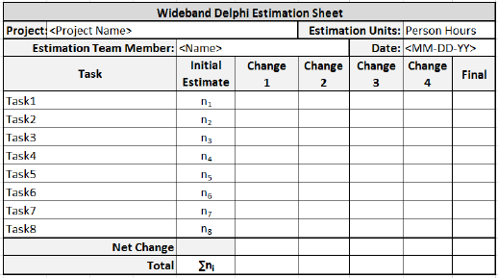

**Step 4** − The moderator calls the Estimation team for the Estimation meeting. If any of the Estimation team members respond saying that the estimates are not ready, the moderator gives more time and resends the Meeting Invite.

**Step 5** − The entire Estimation team assembles for the estimation meeting.

**Step 5.1** − At the beginning of the Estimation meeting, the moderator collects the initial estimates from each of the team members.

**Step 5.2** − He then plots a chart on the whiteboard. He plots each member’s total project estimate as an X on the Round 1 line, without disclosing the corresponding names. The Estimation team gets an idea of the range of estimates, which initially may be large.

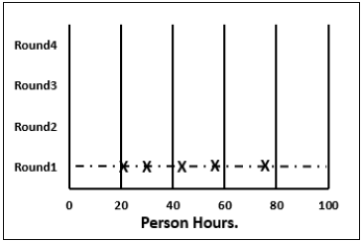

**Step 5.3** − Each team member reads aloud the detailed task list that he/she made, identifying any assumptions made and raising any questions or issues. The task estimates are not disclosed.

The individual detailed task lists contribute to a more complete task list when combined.

**Step 5.4** − The team then discusses any doubt/problem they have about the tasks they have arrived at, assumptions made, and estimation issues.

**Step 5.5** − Each team member then revisits his/her task list and assumptions and makes changes if necessary. The task estimates also may require adjustments based on the discussion, which are noted as **+N Hrs.** for more effort **and –N Hrs**. for less effort.

The team members then combine the changes in the task estimates to arrive at the total project estimate.

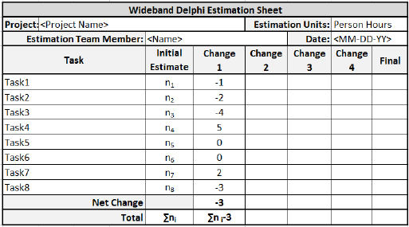

**Step 5.6** − The moderator collects the changed estimates from all the team members and plots them on the Round 2 line.

In this round, the range will be narrower compared to the earlier one, as it is more consensus-based.

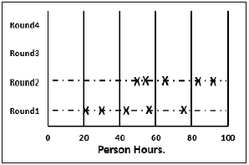

**Step 5.7** − The team then discusses the task modifications they have made and the assumptions.

**Step 5.8** − Each team member then revisits his/her task list and assumptions and makes changes if necessary. The task estimates may also require adjustments based on the discussion.

The team members then once again combine the changes in the task estimate to arrive at the total project estimate.

**Step 5.9** − The moderator collects the changed estimates from all the members again and plots them on the Round 3 line.

Again, in this round, the range will be narrower compared to the earlier one.

**Step 5.10** − Steps 5.7, 5.8, and 5.9 are repeated till one of the following criteria is met −

* Results are converged to an acceptably narrow range.
* All team members are unwilling to change their latest estimates.
* The allotted Estimation meeting time is over.

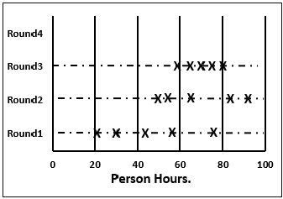

**Step 6** − The Project Manager then assembles the results from the Estimation meeting.

**Step 6.1** − He compiles the individual task lists and the corresponding estimates into a single master task list.

**Step 6.2** − He also combines the individual lists of assumptions.

**Step 6.3** − He then reviews the final task list with the Estimation team.

**OTHER ESTIMATION TECHNIQUES**

1. **FUNCTION POINT ANALYSIS(FPA)**

Function Point Analysis was initially developed by Allan J. Albercht in 1979 at IBM and it has been further modified by the International Function Point Users Group (IFPUG).

FPA provides a standardized method to functionally size the software work product. This work product is the output of software new development and improvement projects for subsequent releases.

It is the software that is relocated to the production application at project implementation. It measures functionality from the user’s point of view i.e. based on what the user requests and receives in return.

 Function Point Analysis (FPA) is a method or set of rules of Functional Size Measurement. It assesses the functionality delivered to its users, based on the user’s external view of the functional requirements. It measures the logical view of an application, not the physically implemented view or the internal technical view.

 The Function Point Analysis technique is used to analyze the functionality delivered by software and the Unadjusted Function Point (UFP) is the unit of measurement.

**Objectives of FPA:**

* The objective of FPA is to measure the functionality that the user requests and receives.
* The objective of FPA is to measure software development and maintenance independently of the technology used for implementation.
* It should be simple enough to minimize the overhead of the measurement process.
* It should be a consistent measure among various projects and organizations.

**Types of FPA:**

* **Transactional Functional Type –**
  + **External Input (EI):** EI processes data or control information that comes from outside the application’s boundary. The EI is an elementary process.
  + **External Output (EO):** EO is an elementary process that generates data or controls the information sent outside the application’s boundary.
  + **External Inquiries (EQ):** EQ is an elementary process made up of an input-output combination that results in data retrieval.

**Data Functional Type –**

* + **Internal Logical File (ILF):** A user-identifiable group of logically related data or control information maintained within the boundary of the application.
  + **External Interface File (EIF):** A group of users recognizable logically related data allusion to the software but maintained within the boundary of another software.

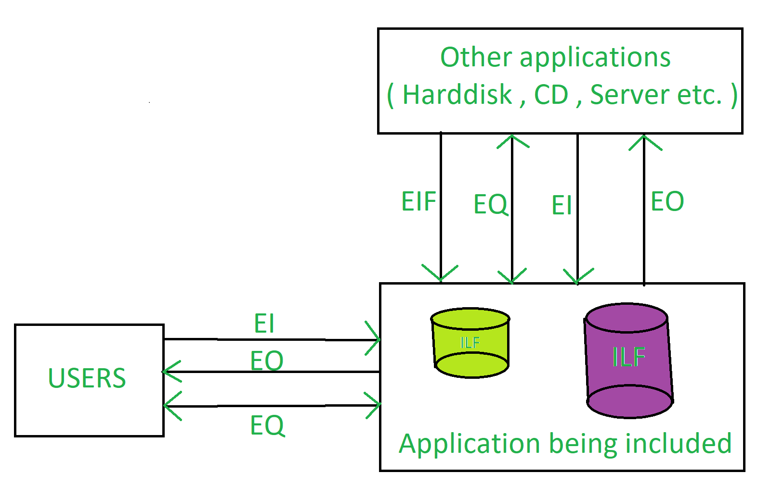

**Benefits of FPA:**

* FPA is a tool to determine the size of a purchased application package by counting all the functions included in the package.
* It is a tool to help users discover the benefit of an application package to their organization by counting functions that specifically match their requirements.
* It is a tool to measure the units of a software product to support quality and productivity analysis.
* It s a vehicle to estimate the cost and resources required for software development and maintenance.
* It is a normalization factor for software comparison.

**The drawback of FPA:**

* It requires a subjective evaluation and involves many judgments.
* Many cost and effort models are based on LOC, so it is necessary to change the function points.
* Compared to LOC, there are fewer research data on function points.
* Run after creating the design spec.
* With subjective judgment, the accuracy rate of the assessment is low.
* Due to the long learning curve, it is not easy to gain proficiency.
* This is a very time-consuming method.

1. **WORK BREAKDOWN STRUCTURE (WBS)**

**WBS** In Project Management and Systems Engineering, is a deliverable-oriented decomposition of a project into smaller components. WBS is a key project deliverable that organizes the team's work into manageable sections. The Project Management Body of Knowledge (PMBOK) defines WBS as a "deliverable oriented hierarchical decomposition of the work to be executed by the project team."

WBS element may be a product, data, service, or any combination thereof. WBS also provides the necessary framework for detailed cost estimation and control along with providing guidance for schedule development and control.

Representation of WBS

WBS is represented as a hierarchical list of project’s work activities. There are two formats of WBS −

* Outline View (Indented Format)
* Tree Structure View (Organizational Chart)

Let us first discuss how to use the outline view for preparing a WBS.

Outline View

The outline view is a very user-friendly layout. It presents a good view of the entire project and allows easy modifications as well. It uses numbers to record the various stages of a project. It looks somewhat similar to the following −

* Software Development
  + Scope
    - Determine project scope
    - Secure project sponsorship
    - Define preliminary resources
    - Secure core resources
    - Scope complete
  + Analysis/Software Requirements
    - Conduct needs analysis
    - Draft preliminary software specifications
    - Develop preliminary budget
    - Review software specifications/budget with the team
    - Incorporate feedback on software specifications
    - Develop delivery timeline
    - Obtain approvals to proceed (concept, timeline, and budget)
    - Secure required resources
    - Analysis complete
  + Design
    - Review preliminary software specifications
    - Develop functional specifications
    - Obtain approval to proceed
    - Design complete
  + Development
    - Review functional specifications
    - Identify modular/tiered design parameters
    - Develop code
    - Developer testing (primary debugging)
    - Development complete
  + Testing
    - Develop unit test plans using product specifications
    - Develop integration test plans using product specifications
  + Training
    - Develop training specifications for end-users
    - Identify training delivery methodology (online, classroom, etc.)
    - Develop training materials
    - Finalize training materials
    - Develop training delivery mechanism
    - Training materials complete
  + Deployment
    - Determine final deployment strategy
    - Develop deployment methodology
    - Secure deployment resources
    - Train support staff
    - Deploy software
    - Deployment complete

Let us now take a look at the tree structure view.

Tree Structure View

The Tree Structure View presents a very easy-to-understand view of the entire project. The following illustration shows how a tree structure view looks like. This type of organizational chart structure can be easily drawn with the features available in MS-Word.

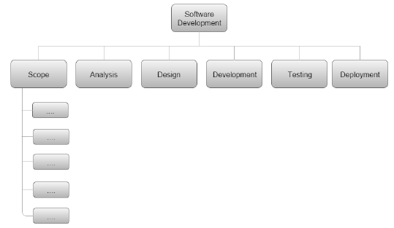

**Types of WBS**

**There are two types of WBS −**

* Functional WBS − In functional WBS, the system is broken based on the functions in the application to be developed. This is useful in estimating the size of the system.
* Activity WBS − In activity WBS, the system is broken based on the activities in the system. The activities are further broken into tasks. This is useful in estimating effort and schedule in the system.

**Estimate Size**

**Step 1** − Start with functional WBS.

**Step 2** − Consider the leaf nodes.

**Step 3** − Use either Analogy or Wideband Delphi to arrive at the size estimates.

**Estimate Effort**

**Step 1**− Use Wideband Delphi Technique to construct WBS. We suggest that the tasks should not be more than 8 hrs. If a task is of larger duration, split it.

**Step 2**− Use Wideband Delphi Technique or Three-point Estimation to arrive at the Effort Estimates for the Tasks.

**Scheduling**

Once the WBS is ready and the size and effort estimates are known, you are ready for scheduling the tasks.

While scheduling the tasks, certain things should be taken into account −

* Precedence − A task that must occur before another is said to have precedence of the other.
* Concurrence − Concurrent tasks are those that can occur at the same time (in parallel).
* Critical Path − Specific set of sequential tasks upon which the project completion date depends.
  + All projects have a critical path.
  + Accelerating non-critical tasks do not directly shorten the schedule.

**Critical Path Method**

Critical Path Method (CPM) is the process for determining and optimizing the critical path. Non-critical path tasks can start earlier or later without impacting the completion date.

Please note that critical path may change to another as you shorten the current one. For example, for WBS in the previous figure, the critical path would be as follows −

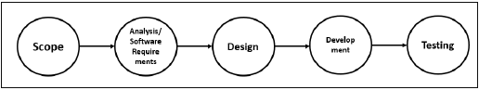

As the project completion date is based on a set of sequential tasks, these tasks are called critical tasks.

The project completion date is not based on the training, documentation and deployment. Such tasks are called non-critical tasks.

**Task Dependency Relationships**

Certain times, while scheduling, you may have to consider task dependency relationships. The important Task Dependency Relationships are −

* Finish-to-Start (FS)
* Finish-to-Finish (FF)

**Finish-to-Start (FS)**

In Finish-to-Start (FS) task dependency relationship, Task B cannot start till Task A is completed.

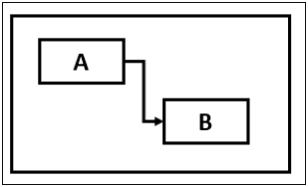

**Finish-to-Finish (FF)**

In Finish-to-Finish (FF) task dependency relationship, Task B cannot finish till Task A is completed.

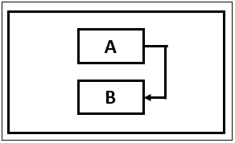

**Gantt Chart**

A Gantt chart is a type of bar chart, adapted by Karol Adamiecki in 1896 and independently by Henry Gantt in the 1910s, that illustrates a project schedule. Gantt charts illustrate the start and finish dates of the terminal elements and summary elements of a project.

You can take the Outline Format in Figure 2 into Microsoft Project to obtain a Gantt Chart View.

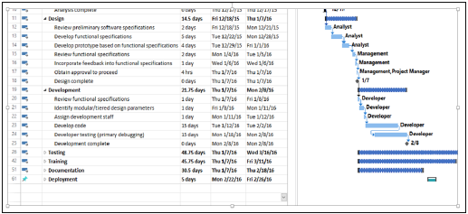

**Milestones**

Milestones are the critical stages in your schedule. They will have a duration of zero and are used to flag that you have completed certain set of tasks. Milestones are usually shown as a diamond.

For example, in the above Gantt Chart, Design Complete and Development Complete are shown as milestones, represented with a diamond shape.

Milestones can be tied to Contract Terms.

**Advantages of Estimation using WBS**

WBS simplifies the process of project estimation to a great extent. It offers the following advantages over other estimation techniques −

* In WBS, the entire work to be done by the project is identified. Hence, by reviewing the WBS with project stakeholders, you will be less likely to omit any work needed to deliver the desired project deliverables.
* WBS results in more accurate cost and schedule estimates.
* The project manager obtains team participation to finalize the WBS. This involvement of the team generates enthusiasm and responsibility in the project.
* WBS provides a basis for task assignments. As a precise task is allocated to a particular team member who would be accountable for its accomplishment.
* WBS enables monitoring and controlling at task level. This allows you to measure progress and ensure that your project will be delivered on time.

References

<https://www.tutorialspoint.com/estimation_techniques/estimation_techniques_wideband_delphi.htm>

<https://www.geeksforgeeks.org/software-engineering-functional-point-fp-analysis/>

<https://www.tutorialspoint.com/estimation_techniques/estimation_techniques_work_breakdown_structure.htm>